Steps performed end to end

Data had been in four different formats in four columns for five cities. So first step is to load the five city files to five dataframes with a new column “City” and merge them as a single dataframe.
df5['City']=pd.Series(dtype='object')
df5["City"].fillna(value='Bangalore',inplace=True)

df=pd.concat([df1,df2,df3,df4,df5])

Seperating the columns to different fields using json normalize

df["new_car_detail"]=df["new_car_detail"].apply(lambda i:json.loads(i.replace("'",'"').replace("None","1")))

newdf1=pd.json_normalize(df["new_car_detail"]) # first column to 19 columns

Remove unwanted columns and add required columns from other df
finaldf=pd.concat([finaldf,df["City"]],axis=1)

Exploring the values present in the columns
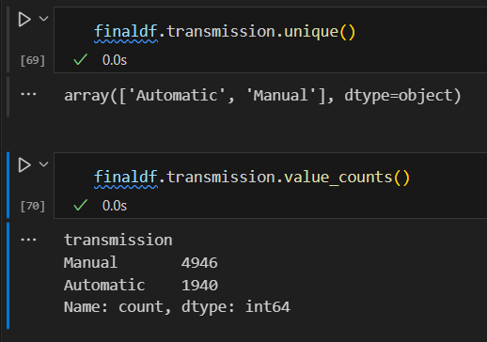

Checking duplicates and deleting them
finaldf.duplicated().sum()
finaldf=finaldf.drop_duplicates()

Changing data types of number columns from object to int/float
finaldf['km'] = finaldf['km'].str.replace(',', '').astype(int)

finaldf.ownerNo=finaldf.ownerNo.astype(int)
finaldf.Engine=finaldf.Engine.astype(int)

Renaming the columns meaningful
finaldf.rename(columns={'ft':'FuelType'},inplace=True)

Encoding the categorical column to numeric
finaldf["City"]=le.fit_transform(finaldf["City"])

Correlation
my_matrix=finaldf.corr().round(2)

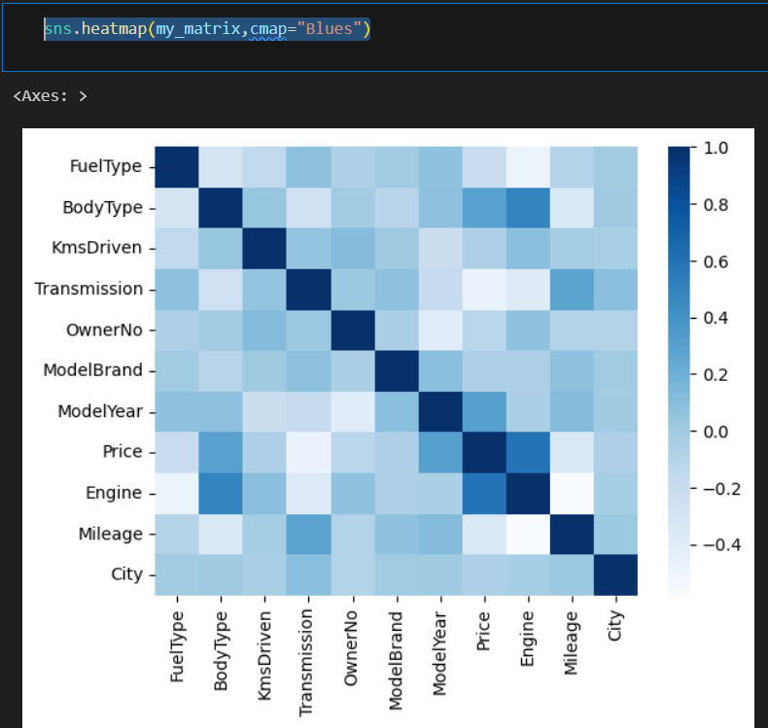

Exploratory data analysis

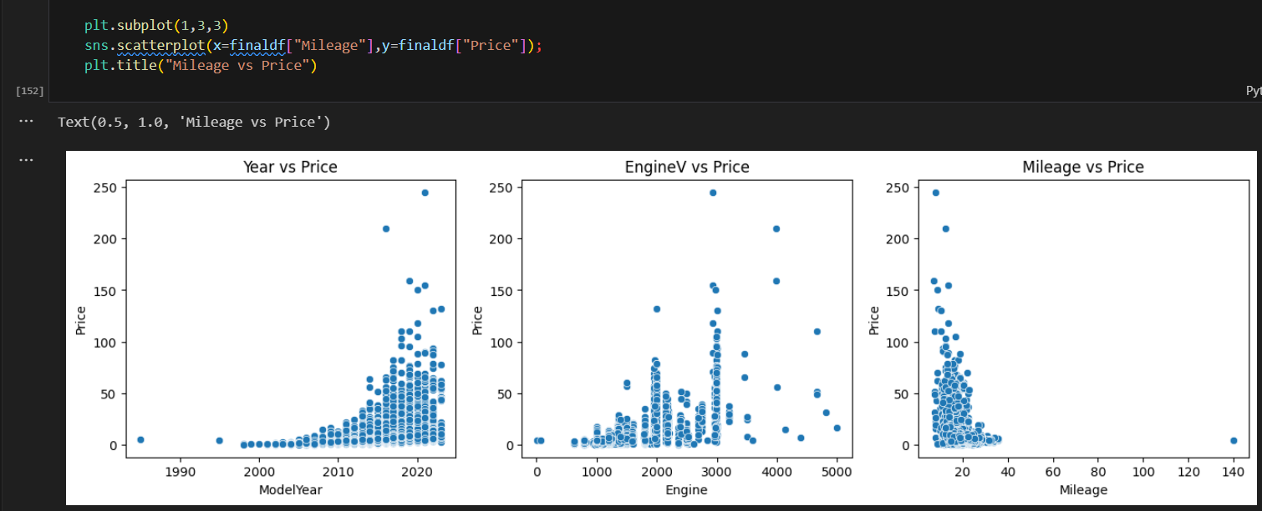

Outliers removal in all numerical columns

Before outlier removal,
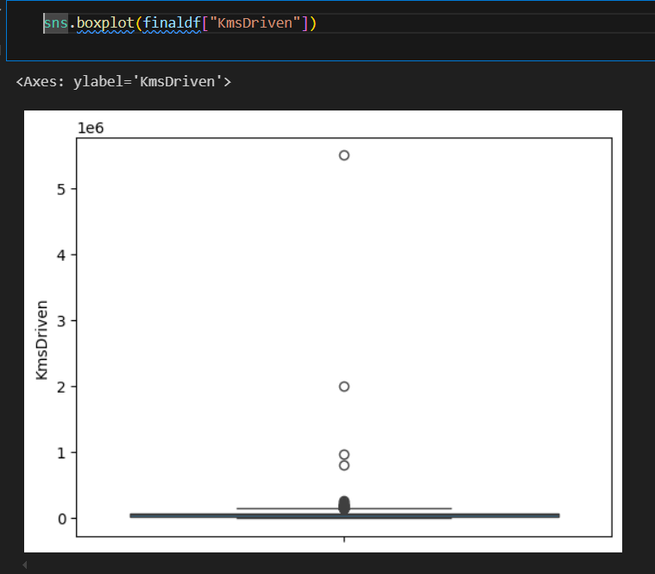
After outlier removal
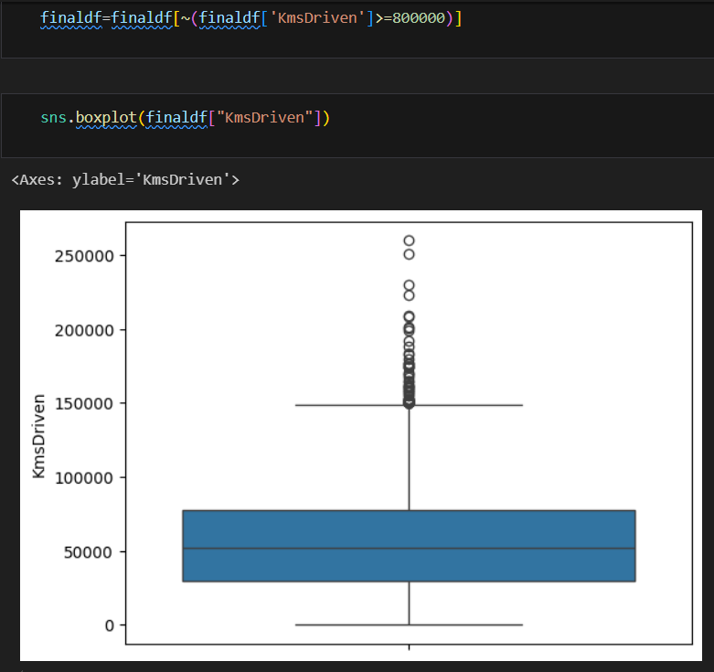

Store Future matrix in X and Target in Y
X=finaldf.drop(["Price"],axis=1)
Y=finaldf["Price"]

Splitting the data set in to training and testing set

X_train,X_test,Y_train,Y_test=train_test_split(X,Y,test_size=0.20,random_state=42)

Import the models
xg= XGBRegressor()
xg.fit(X_train,Y_train)

y_pred5=xg.predict(X_test)
score5=metrics.r2_score(Y_test,y_pred5)

Evaluating the algorithms and comparing the R2 scores

Here are the three common evaluation matrices for regression problems:
- Mean absolute error(MAE)
- Mean Square Error(MSE)
- R Squared Error

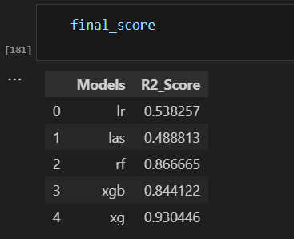

Min max scaling
from sklearn.preprocessing import MinMaxScaler
scaler=MinMaxScaler().fit(X_train)# scalar object will understand the value in between min to max from xtrain
x_train_scaled=scaler.transform(X_train)# implement and transfer the xtrain and save it to x_train_scaled based on xtrain
x_test_scaled=scaler.transform(X_test)# implement and transfer the xtest and save it as x_test_scaled based on xtrain
x_train_scaled

Hyper parameter tuning

Save the model
joblib.dump(xg_final,'car_price_predictor_xg') #saving the model named car_price_predictor_xg

xgmodel=joblib.load('car_price_predictor_xg')

Prediction on new data
newvalue=[[4,5,20000,1,1,20,2015,1196,15,1]]
result=xgmodel.predict(newvalue)
print(result)

Streamlit application development and deployment

https://durga-r-m-car-price-prediction-carprice-prediction-ui-musn3e.streamlit.app/
